VEFF is a project of the Ministry of Education and Sports supporting partnerships between vocational training providers and interested enterprises in the field of technical and vocational education and training, specifically under the Dual-Cooperative Training (DCT) Approach. Thereby VEFF call regularly in line with the school year for project proposals. VEFF applies a two-steps approach:
- Submitting a rather general Expression of Interest (EoI, step 1, form for download), which will be checked for eligibility and appraised by a combined DTVE/VEFF panel.
Successful applicants will be invited to submit a detailed Grant Application (GA, step 2)
- Submitting a detailed Grant Application, which will be again checked for eligibility and appraised by a combined DTVE/VEFF panel. If the applicants wish the preparation of the Grant Application can be supported by a DCT advisor. The final decision about funding of a program is taken by the VEFF Steering Committee and – if approved – lead to the singing of a Funding Agreement between VTI, enterprise partners and VEFF and releases a comprehensive packages consisting of in cash or kind support.
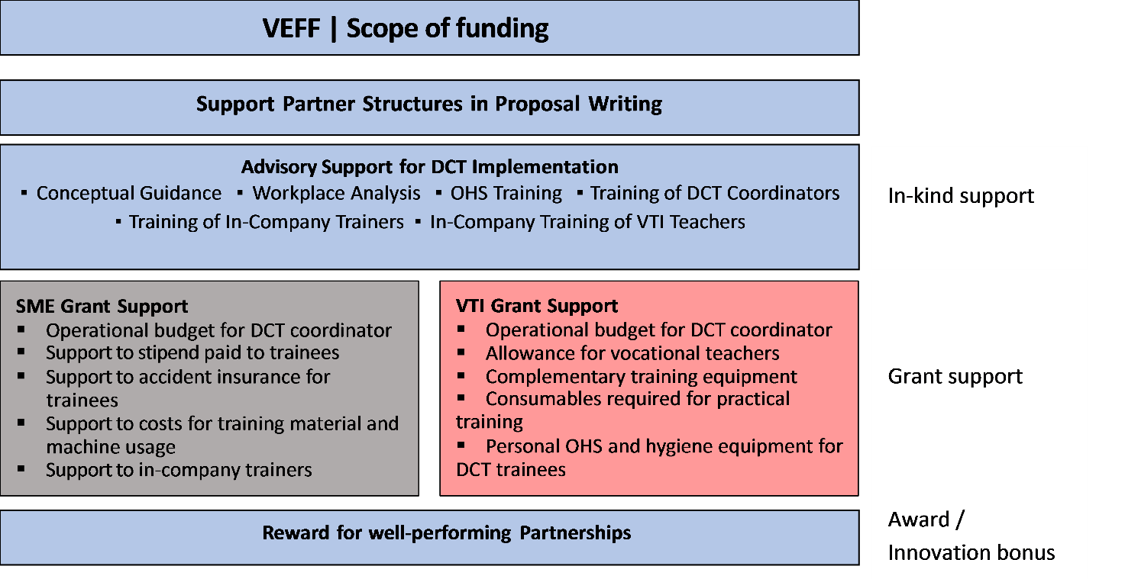
VEFF Phase II is accepting Expressions of Interest for vocational training programs starting end of 2023 for the school year 2024/25 and will announce this on https://www.facebook.com/VEFFLaos here of DCT-SC web portal as well as through the DTVE channels.
The main criteria for eligibility are:
- Being jointly submitted by one VTI and at least one enterprise,
- Aiming at start of training in the school year 2024/25,
- Requiring financial support for up to 3 years (until October 2027)
- Applicants are encouraged to promote the participation of girls and women, people from different ethnic groups, people with disabilities, and people from disadvantaged backgrounds in TVET.
- The number of trainees enrolled including the percentage of female enrolment will be considered in the appraisal process.
EoI must be submitted to the VEFF Office not later than 15.01.2024.
The Vocational Education Financing Facility (VEFF) is a project under Lao-German Development Cooperation, implemented by the Ministry of Education and Sports, co-funded by the German Government through KfW Development Bank. The overarching objective of the Vocational Education Financing Facility (VEFF) is to improve the quality and the labour market relevance of TVET and Skills Development as well as to support the employment of vocational institutes’ graduates, specifically by promoting cooperative vocational training courses jointly offered by schools and companies (Dual Cooperative Training - DCT). VEFF is operating in form of a challenge fund. For the school year 2024-25, the 15 best-qualified of all received applications will get funded.

